***Sentimental Analysis on the Twitter comments by the Twitter users on the Greece fire incident***

**MSC Information technology, UFCFJJ-15-M-Social Media & Web Science, Student No:20054854**

**Introduction & Research**

The Greece fire has been reported on 4th August 2021, the incident has been a threat to European countries and the fire incident is trending all over the world.

**AIM:** This poster aims to demonstrate the sentimental reactions of Twitter users all over the globe.

**Research Questions on the Greece fire accident:**

1. What are the Sentimental comments posted on the Twitter by the peoples around the world?
2. How do Twitter users respond (Rewetted) to the Greece fire incident?
3. How the Twitter users reacted to the incident on the scale of Negative, Neutral & Positive?

**Background Research:**

* Based on the Greece fire accidents which happened a few times earlier, there have been several types of research made. But based on the Twitter data there has been no research made before.
* The Twitter data are classified based on the user sentiments and analysis of the reactions to the tragedy.

The response to the fire being immediate, indeed, sad, lost, help. The negative incidents always reach the public quicker and stronger emotions tend to elicit stronger and quicker (OpenStax CNX, 2021)

**Methodology:**

**Data Collection:** Twitter data was collected using #prayforgreece & #greecefire for more than 24 hours to analyze the reactions of the tweets.

**Sources:** Hawksey Tags V6.1 was used to collect the data from Twitter.

**Method/Coding:** The collected data on the Twitter hashtag has been undergone for the separation of “Types of Tweets” (Retweeted/Original) using the Microsoft Excel formula. Using the Azure Machine learning add-on in Microsoft excel (Azure ML, 2021) the sentiments of Twitter have been classified and identified with the percentage refer Fig 1.

**Coding:** “R” Programming was used to identify the sentiments based on the tweet's message (Twitter Sentiment Analysis R, 2021). The sentiments are classified on the frequency of the usage in the tweets and presented in Fig 1.

**Geolocations:** The geo-locations of the Twitter users based on the sentimental tweets are gathered and plotted in Microsoft Excel and presented in Fig 2.

**Dataset:**

* #greecefire – 2216 tweets were downloaded for the analysis of Twitter user reactions
* #Prayforgreece – 2294 tweets were taken into consideration for the evaluation of the Twitter user's sentimental responses.
* For the geolocations, the users without locations have been ignored and the map has been plotted with available user locations.

**Results:**

* Twitter reactions for the #prayforgreece is given below

|  |  |  |
| --- | --- | --- |
| Negative - 74.71% | A picture containing text, nature, house, old  Description automatically generated  Neutral - 21.59% | A picture containing tree, outdoor, smoke, coming  Description automatically generated  Positive - 3.71% |

Figures Source - (Greece fire, 2021)

* The Sentiments types of the #prayforgreece in correlations with the types of Twitter for both hashtags compared for the sentimental analysis are provided below.

|  |  |  |
| --- | --- | --- |
|  |  |  |
| Sentiments Type Vs Types of Twitter (Original / Retweeted)  Figures source – Tags twitter data using #PrayForGreece & #Greecefire | | |

|  |  |  |
| --- | --- | --- |
| **Sentiment** | **Sentiments Total Counts** | **% of Sentiment** |
| Angry | 312 | 14.09% |
| Help | 146 | 6.59% |
| Hope | 300 | 13.54% |
| Horrible | 838 | 37.83% |
| Lost | 3 | 0.14% |
| negative | 284 | 12.82% |
| positive | 12 | 0.54% |
| Sad | 196 | 8.85% |
| Vain | 3 | 0.14% |
| Worst | 121 | 5.46% |

|  |  |  |  |  |  |  |  |  |  |  |  |  |
| --- | --- | --- | --- | --- | --- | --- | --- | --- | --- | --- | --- | --- |
| |  |  |  | | --- | --- | --- | | **Sentiment** | **Total no of Sentiments** | **% of Sentiments** | | negative | 1713 | 74.71% | | neutral | 495 | 21.59% | | Positive | 85 | 3.71% | |

|  |
| --- |
| Fig -1 (#Greecefire twitter, 2021) Vs ( #PrayForGreece) |

* The % of the Twitter sentiments for the #Greecefire is provided in the 3D graphical chart.

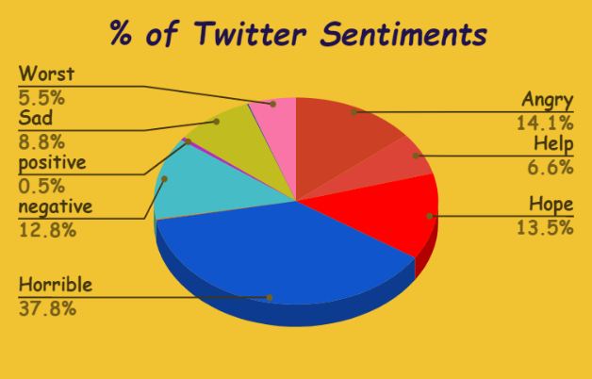

* The Twitter user locations tweeted for the above-said hashtags, based on the user locations the data geolocations have been mapped and displayed below.

|  |
| --- |
| Fig – 2 (Geolocations of Twitter users of #greecefire) |

**Conclusion:**

1. The #greecefire has sentimental words such as help, worst, horrible, negative, hope, sad, angry, positive, vain & lost out of which the word horrible has been used in 838 tweets with the highest % of 37.8. whereas the word lost & vain words are the lowest sentiments with 0.14%.
2. The tweets are more emotionally loaded with multiple words that express, enhance or modify sentiment.
3. The word Angry is frequently used by users in Australia which is clearly shown in Fig-2 geolocations.
4. The sentimental analysis #prayforgreece has the negative sentimental feeling of 74.71% of tweets.

**Limitations & Recommendations:**

The #greecefire has few sentimental words which have been sorted out with the “R” programming. whereas the #prayforgreece, the data which are all not in the English language has been ignored. Some of the data are originally from the Greece which is not in English therefore the tweets are not considered/ignored. The future recommendation research should consider the other language tweeted and translate into English and included for the dataset analysis.

**References:**

1. Cnx.org. 2021. *OpenStax CNX*. [online] Available at: <https://cnx.org/contents/LTjQLL1F@40.7:vsCCnNdd@150/The-Psychology-Of-Emotions-Feelings-and-Thoughts> [Accessed 8 August 2021].
2. Azure Machine Learning. 2021. Azure ML. [online] Available at: <https://appsource.microsoft.com/en-us/product/office/wa104379638?tab=overview> [Accessed 8 August 2021].
3. Medium. 2021. Twitter Sentiment Analysis R. [online] Available at: <https://towardsdatascience.com/twitter-sentiment-analysis-and-visualization-using-r-22e1f70f6967> [Accessed 8 August 2021].
4. Google.com. 2021. greece fire. [online] Available at: <https://www.google.com/search?q=greece+fire&rlz=1C1CHBD_en-GBGB957GB957&sxsrf=ALeKk03MU1rvMOu5uvIFWsgcKuA_QtFNpg:1628462122690&source=lnms&tbm=isch&sa=X&ved=2ahUKEwjtlumSvqLyAhUMH-wKHdVnAPAQ_AUoAXoECAEQAw&biw=1366&bih=625> [Accessed 8 August 2021].